# Department of Computing

# MATH 333: Numerical Analysis

# Class: BSCS-6AB

# Lab 4: Newton Raphson Method

# Date: February 15, 2019

# Time: 10:00 – 12:50hrs & 14:00-16:50hrs

# Instructor: Atifa Kanwal

# Lab Engineer: Mr.Azaz Farooq

Arifullah Jan | 186943 | BSCS6A

# Lab 4: Newton Raphson Method

CLO1: Drive Algorithm for different Numerical Techniques

**Introduction**

Newton Raphson method is a numerical method. Newton Raphson method allows us to find the roots of functions.

**Objectives**

The purpose of this lab is to get familiar with Newton Raphson Method

**Tools/Software Requirement**

Matlab R2016a

**Description**

For Newton Raphson method, the function must be differentiable. The formula for Newton

Raphson method is :

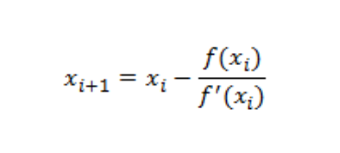

**Main Steps**

Declare function.

● Calculate its derivative.

● Perform iteration.

**Lab Task**

Implement Newton Raphson method as function. Take function, initial guess and tolerance as input from user. Calculate its derivative and find its roots.

**Note**: For derivative, investigate “sym” and “diff” command.

**Atleast use any two functions to calculate root.**

**Deliverables**

Submit single word file with matlab code and screen shot of Output.

Solution:

# Task 1:

%The Newton Raphson Method

clc;

close all;

clear all;

syms x;

%

f=exp(-x)-x; %Enter the Function here

%f=x*exp(x)-1; %Enter the Function here

g=diff(f); %The Derivative of the Function

n=input('Enter the number of decimal places:');

epsilon = 5*10^-(n+1)

x0 = input('Enter the intial approximation:');

for i=1:100

f0=vpa(subs(f,x,x0)); %Calculating the value of function at x0

f0_der=vpa(subs(g,x,x0)); %Calculating the value of function derivative at x0

y=x0-f0/f0_der; % The Formula

err=abs(y-x0);

if err<epsilon %checking the amount of error at each iteration

break

end

x0=y;

end

y = y - rem(y,10^-n); %Displaying upto required decimal places

fprintf('The Root is : %f \n',y);

fprintf('No. of Iterations : %d\n',i);

## Function 1

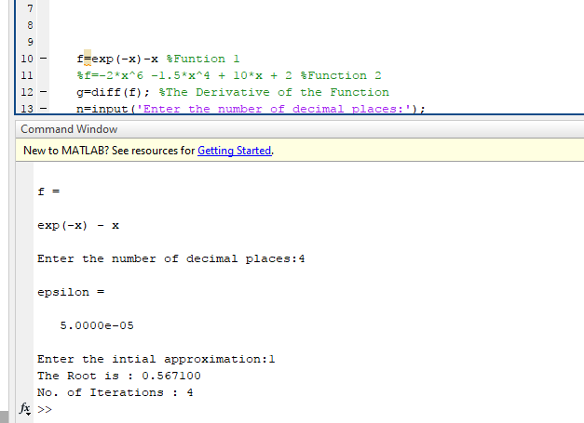

## Function 2

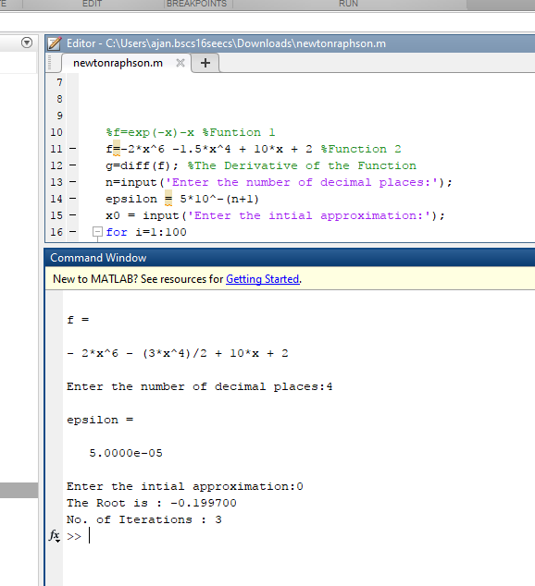

When the method diverges

